PROJECT REPORT ON

**SOLAR INSOLATION LEVEL RECORDER**

**AND**

**DATA LOGGER**

SPONSORED BY

INDIAN METEOROLOGICAL DEPARTMENT, PUNE

SUBMITTED BY

RAHUL NANGARE

PRATIK PAINJANE

ANUPSINGH PARDESHI

DEPARTMENT OF ELECTRONICS & TELECOMMUNICATION P.E.S.’S MODERN COLLEGE OF ENGINEERING PUNE – 411 005.

UNIVERSITY OF PUNE

2013-14

**CERTIFICATE**

This is to certify that following students

### 

### NAME EXAM NO.

NANGARE RAHUL ANANDRAO

PAINJANE PRATIK RAJESH

PARDESHI ANUPSINGH KISHORSINGH

of B.E.,E&TC have successfully completed the project titled **‘**SOLAR INSOLATION LEVEL RECORDER AND DATA LOGGER**’** during the academic during the academic year 2013-14.This report is submitted as per requirement of B.E. E&TC Engineering as prescribed by University of Pune.

### 

PROF. V. N. PATIL MRS. S. D. BORDE

H. O. D. Project Guide

### 

### ACKNOWLEDGEMENT

We are greatly thankful to a great number of people, without whose help, guidance and efforts to this work would have not been possible. We express with all sincerity and deep sense of gratitude our indebtedness of **Prof. MRS. S. D. BORDE**.

We are equally thankful to **Prof. Mr. V. N. Patil**, the H.O.D of E&TC department for providing us facilities to carry out project work.

We would also like to thank our entire staff members for their kind co-operation and help. We also convey our sincere regard towards our parents because their blessings and guidance always enlightened our path. We would like to thank personally our friends for their supports and joint efforts.

We conclude by thanking our respected Principal for making available all college facilities to us.

ABSTRACT

The Sun is the ultimate source of energy for the Earth. Its energy is both clean and free of cost. So maximizing the use of solar energy help to take the load off from fossil fuels like petrol, diesel, etc. and limit the emission of carbon dioxide hence preventing the pollution. It is also necessary to find out the area where this energy is more, so that the solar panel can be installed in such area to get maximum outcome. So to measure solar insolation level at a particular area we have designed a system. This system will measure the incident power per unit area and will also give the period of maximum sunshine.

The system comprises of photodiode, RTC (Real Time Clock), Servo Motors, Microcontroller and LCD. Photodiode gives output proportional to sun intensity. This output is sent to microcontroller, the output of photodiode and corresponding time is saved in the memory. We are continuously logging data by reading output of photodiode after particular interval of time. While the data is logged, photodiode tracks the sun so that Direct Normal Incident radiation is only measured. After whole data is logged, it is sent to PC serially for further analysis.

### TABLE OF CONTENTS:

Sr. Title Page No.

1. Introduction 6
2. Literature survey 7
3. Block diagram, description & Working 11
4. Hardware Specification 14
5. Algorithm 18
6. Future Modifications 19
7. Applications 20
8. Results 21
9. Conclusion 22
10. References 23

### INTRODUCTION

Solar energy is very large inexhaustible source of energy. The power from the sun intercepted by the earth is approximately 1.8*10^11 MW, which is many thousands of times larger than the present consumption rate on the earth of all commercial energy sources. Thus in, principle, solar energy could supply all present and future needs of the world on a continuous basis. This makes it one of the most promising unconventional energy sources.

In addition to its size, solar energy has two other factors in its favor, first unlike fossil fuel and nuclear power, it is an environmentally clean source of energy. Second it is free and available in adequate quantities in almost all parts of the world where people live. The sun as we know is the back bone of living kingdom, it’s all because of which there is life on the earth. The solar radiation matters most on the life of the animals and human.

While quantitative information on solar radiation is needed in many studies such as meteorology and the design of solar systems, it is difficult to obtain these data in remote areas where relevant data are required. Therefore we are making an attempt to create a system which will help us to monitor the direct radiation spread over a specific area. Monitor as described herein deals with measuring, recording and transmission of measured data to computer.

### LITERATURE SURVEY

**Pyranometer:** Pyranometer is an instrument which measures either global radiation or diffuse radiation falling on a horizontal surface. Basically the pyranometer consists of a ‘black’ surface which heats up when exposed to solar radiation.

Basically the pyranometer consists of a ‘black’ surface which heats up when exposed to solar radiation. Its temperature increases until the rate of heat gain by the solar radiation equals the rate of heat loss by convection. The hot junction of a thermopile is attached to the black surface while the cold junctions are located under a guard plate so that they do not receive the radiation directly. As a result, an EMF is generated. This EMF which is usually in the range of 0 to 10 mV can be read, recorded or integrated over a period of time and is a measure of the global radiation.

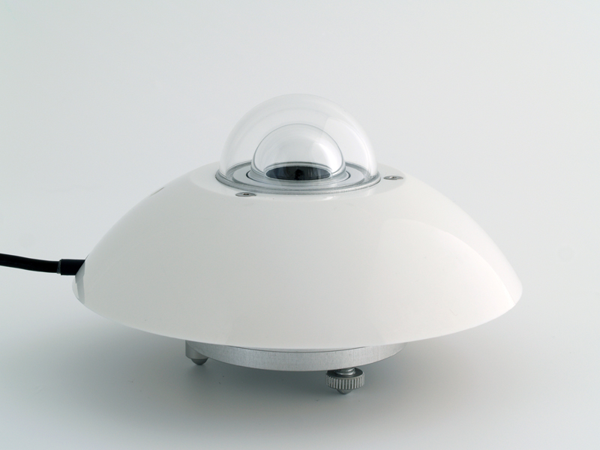Fig. 1 Pyranometer

* 1. **Sunshine recorder:** The duration of bright sunshine in a day is measured by means of a sunshine recorder. The sun’s rays are focused by a glass sphere to a point on a card strip held in a groove in a spherical bowl mounted concentrically with the sphere.

Whenever there is bright sunshine, the image formed is intense enough to burn a spot on the card strip. Through the day as the sun moves across the sky, the image moves along the strip. Thus, a burnt trace whose length is proportional to duration of sunshine is obtained on the strip.

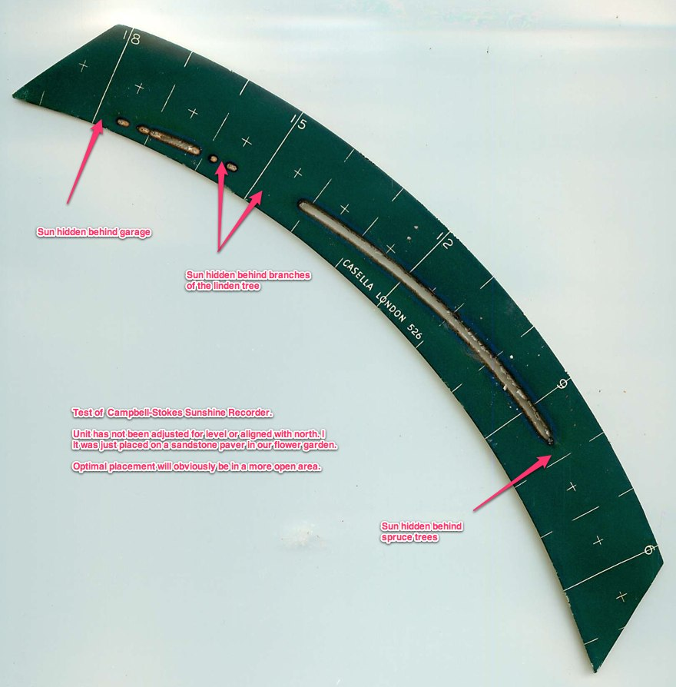

Fig. 2 Strip used for Sunshine Recorder

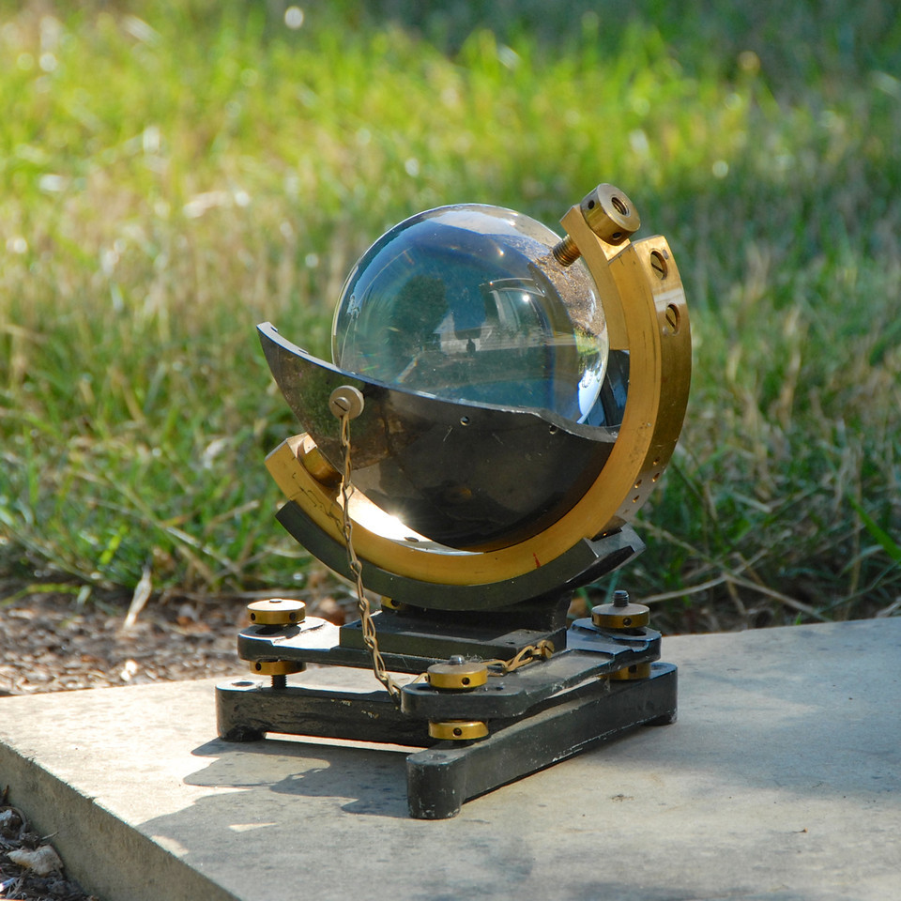

Fig.3 Sunshine Recorder

* 1. **Pyrheliometer:**

A Pyrheliometer is used measure Direct Normal incidence irradiance falling on a surface normal to the sunrays. In contrast to pyranometer , the black absorber plate is located at the of the collimating tube.

The tube aligned with direction of the sunrays with the help of a two axis tracking mechanism and an alignment indicator. Thus the black plate receives only beam radiations and small amount of diffused radiations falling within the 5 degree ‘acceptance angle’ of the instrument.

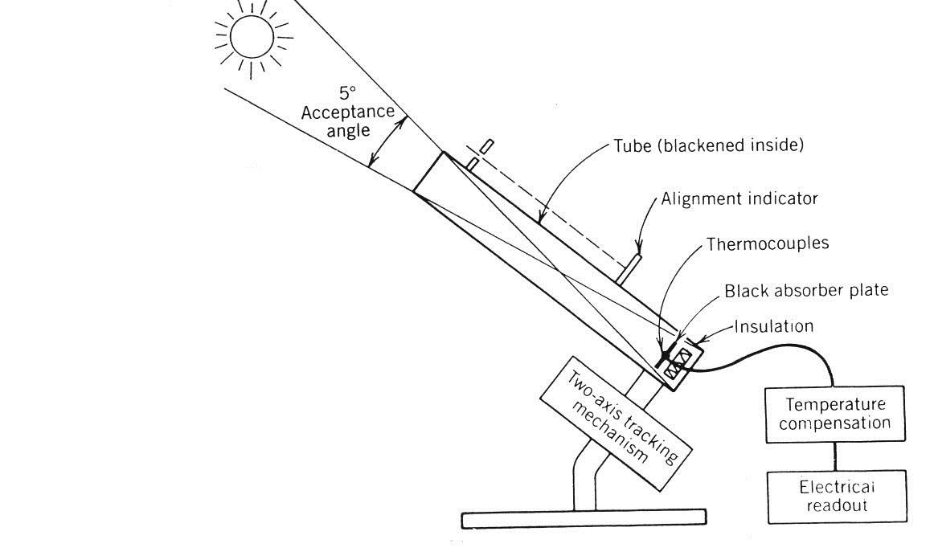

Fig.4 Pyrheliometer

**2.4** ‘A Microcontroller-Based Data Acquisition System for Solar Radiation and Environmental Monitoring’ IEEE paper published by Raphael Mukaro and Xavier Francis Carelse, in this paper the pyranometer is use as a sensor to measure solar radiation and the data in stored in EEPROM. The stored data is then serially sent to PC.

**2.5** ‘Testing and Calibration of an Ultraviolet-A Radiation Sensor Based on GaN Photodiode’ paper published by J. THEYIRAKUMAR in Sains Malaysiana Journal. In this paper, an ultraviolet A (UVA) radiation intensity sensor with esponsivity in the wavelength range of 320-360 nm was developed based on a gallium nitride (GaN) photodiode. The output of sensor was tested and calibrated successfully.

**2.6** ‘Design and Fabrication of A Low-Cost Data Logger for Solar Energy Parameters’ paper by K. N. Akposionu and A. O. C Nwokoye in Journal of Energy Technologies and Policy.

In this paper, the solar energy parameters are measured. Temperature reading is measured using LM35 sensor and the solar radiation variation is measured using solar panel. Stored data in EEPROM is sent serially to PC for further analysis.

1. **BLOCK DIAGRAM, DESCRIPTION & WORKING**

**3.1 BLOACK DIAGRAM:**

Fig.5 Block Diagram of system

* 1. **Description:**

3.2.1 Battery:

1) It is used to give supply to Microcontroller and Servo motors.

2) For microcontroller we require 5V and for servo we require 6V supply.

3.2.2 Sensor:

1. To measure radiation power, we are using a photodiode which has on-chip amplifier. The photodiode output voltage is proportional to the incident solar power.
2. The integrated combination of photodiode and trans-impedance amplifier on a single chip eliminates the problem encountered in discrete design.

3.2.3 Microcontroller:

1. This is CPU of our project. The various functions of microcontroller are

* To initialize LCD and Serial Communication
* To covert analog value to digital
* To store values in memory
* To display result on LCD

3.2.4 RTC:

1. The RTC is used to generate the date and time.
2. The RTC uses I2C standard to communicate.

3.2.5 Servo motor:

1. The tracking mechanism is done by using two servo motors.
2. It helps to keep photodiode perpendicular with direct sunrays.
   * 1. LCD:

1) It is 16 characters x 2 lines.

2) It is used to display the result which shows the value of radiation and time.

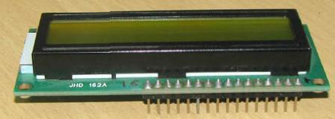

Fig.6 LCD

3.2.7 GUI:

LABVIEW: To display graph of solar radiation versus time.

* 1. **WORKING:**

In this project there are following blocks:

* Battery and power supply
* Sensors
* Microcontroller
* RTC
* Servo Motors
* LCD

3.3.1 Battery and power supply:

Here we are using battery as main source. The battery voltage is further divided in order to give supply to Microcontroller and servo motors.

Different voltage to different sections is given through voltage regulators.

3.3.2 Sensors:

The sensor here is a photodiode. It has on-chip trans-impedance amplifier. The output voltage of the photodiode is proportional to the incident radiation.

In maximum light the output voltage is equal to the biased voltage and in the dark it almost equal to zero.

The output voltage is given to the analog pin of microcontroller.

3.3.3 Microcontroller:

The microcontroller the analog value from the photodiode and converts it into digital value by on-chip Analog-to-Digital converter. Then this value along with the corresponding time is saved in the memory.

The microcontroller also controls motors used in tracking system.

3.3.4 RTC:

RTC (Real time clock) is used to keep the time and date. It has an auxiliary battery supply so that even in power failure it will be always updated.

It uses the I2C standard for communication so it only needs two pins.

3.3.5 Servo motors:

Two Servo motors are used in the tracking system for the rotation on 2 Axes.

Motor has three connections. Vcc, Ground and control pin. The control pin is connected to PWM pin of the controller. The supply is given through the voltage regulator.

* + 1. LCD:

The LCD is used to display the radiation value and the corresponding time.

It is used in the 4-bit mode in order to save the pins.

1. **Hardware Specification:**

4.1 ATMEL-Atmega328:

The Atmega328 is a low power, high performance, CMOS 8-bit microcontroller based on the AVR enhanced RISC architecture. Atmega328 provides 32 K bytes of in-system self programmable memory with read while write capability and 1Kbyte EPROM.

FEATURES:

1) 32 Kb of In-System self-programmable flash.

2) 1 Kb of EEPROM.

3) 8 Channel 10 Bit ADC.

4) 6 PWM channels

5) 6 Analog Pins.

6) UART to USB connector (Helpful in programming on Laptop).

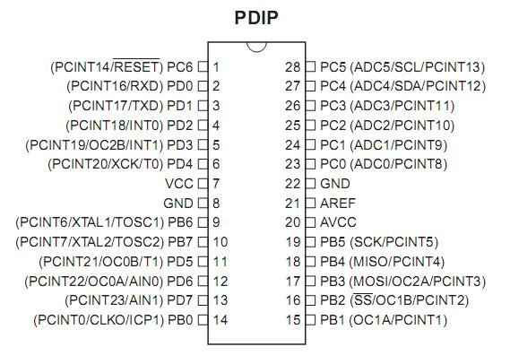 7) Arduino ATMEGA 328 board available.

Fig. 7 Pin diagram of Atmega 328

4.2 RTC DS1307:

DS1307 serial real time clock is a low power, full binary coded decimal clock/ calendar plus 56 bytes of NV SRAM. Address and data are transferred serially through an I2C, bidirectional bus.

The DS1307 has a built in power sense circuit that detects power failure and automatically switches to the backup supply. Time keeping operation continues while the part operates from the backup supply.

Features:

1) Counts seconds, Minutes, Hours, Date of Month.

2) I2C serial Interface (SCL & SDA pin required).

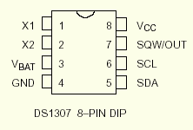 3) Available in 8-pin DIP.

Fig. 8 Pin diagram of RTC DS1307

4.3 OPT-101:

OPT101 is monolithic photodiode with on chip trans-impedance amplifier. Output voltage increases linearly with light intensity. The amplifier is designed for single or dual power supply operation making it ideal for battery operated operations.

Photodiode is operated in the photo-conductive mode for excellent linearity and low dark current.

Features:

1) Monolithic photodiode & single Trans-impedance Amplifier.

2) Single supply: +2.7V to +36 V.

3) Internal 1 MΏ feedback resistor.

4) High Responsivity: 0.45A/W (650nm)

5) Temperature range:0 to +70 degree Celsius

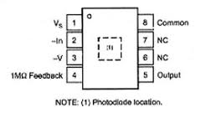

4.4Servo motor:

A servo motor is a rotary actuator that allows for precise control of angular position, velocity and acceleration. It consists of a suitable motor coupled to a sensor for position feedback.

Features:

Operating voltage: 4.8-6V

Control system: pulse width control 1520 µsec Neutral

Operating temperature range: -20 to + 60 degree Celsius

Operating speed: 4.8V-0.23 sec/60 degrees at no load

6.0V-0.19 sec/60 degrees at no load

Torque: 4.8V-3.2Kg/cm

6.0V-4.1Kg/cm

Algorithm:

1. Start the system
2. Take analog value from sensor
3. Convert it in Digital
4. Store it in the memory with corresponding time
5. Wait for defined interval
6. Go to step 2
7. At the end of the day, stop storing data
8. Stored data is sent serially on Computer
9. Turn off the system

Future Modifications:

* To make system portable, solar panel can be used as a supply.
* By using GSM module recorded data can be accessed by SMS service.
* By using GPRS the data can be uploaded on the web server for direct data analysis.
* Array of photodiode can be used to increase the accuracy of measurement.

Applications:

* For the meteorological studies.

* For the solar systems.

* Can be used in remote areas where it is difficult to install conventional system

* For the researchers to study the effect of solar radiation on different living things such as plant, animals etc.

Results:

* We have measured the Global Radiation using the OPT101
* We have interfaced the sensor OPT101 with the microcontroller ATMEGA328.
* We have displayed the result on the LCD
* We also interfaced RTC DS1307 with microcontroller and saw the output on LCD.

|  |  |
| --- | --- |
| **Time** | **Output** |
| Morning |  |
| Afternoon |  |
| Evening |  |

References:

* IEEE Transaction on instrumentation and measurement volume 48 No 6
* ‘SOLAR ENERGY’ principles of thermal collection and storage by- S P Sukhatme and J K Nayak
* pveducation.org
* people.ece.cornell.edu